OUTING NAME: Henry’s Fork

DATE AND TIME: June 13-16

TYPE: Multiple Day

BVFF Angler Challenges: Cutthroat Slam

FISH SPECIES: Cutthroat, Rainbow, Brown, Book trout, Mountain Whitefish

LICENSE NEEDED: Idaho. If going to Yellowstone, you will need a Yellowstone Fishing Licenses. State licenses are not accepted.

LODGING, RV, AND CAMPING FACILITIES:

BVFF Host Home Base will be the Warm River Campground

BVFF HOST(S) AND OUTING BASE LOCATION: Warm River Campground; Host Paul Gray is holding tent site 16 which will serve as final night BBQ and location for BVFF questions.

RV and tent sites can be booked at Recreation.gov. The link to WRCG is https://www.recreation.gov/camping/campgrounds/232223 to Book a site log in is required. Check tent sites whether they are single or multiple.

A good resource for questions about the campground is the Targhee National Forest District Office in Ashton: 208 652 7442.

Other lodging options in the area include:

Jolly Campground ---some BVFF are staying at Jolly
1146 North 3400
East Ashton, ID 83420
208 652 2267
Jollycamper@gmail.com

They get booked early but have a generous cancellation policy: 100% refund before 14 days, 50% before 7 days, non refundable after 6 days
All reservations are through Rover Pass. Link to reservation system is through the website…http://jolleycamper.com/

Silver Horseshoe Inn----they are one of the sponsors of the BVFF!!
22 N. Bridge Street
St. Anthony, ID 83445
208-624-2400
https://www.silverhorseshoeinn.com/

TRR Ranch:
208 652 3750
https://threeriversranch.com/the-lodge/

Eagle Park Lodge, RV and Camping
208 652 3699
https://www.eaglepeaklodge.com/new-page

Warm River campground
208 557 5900
Reservations can be made at www.recreation.gov. Reservations must be made 4 days ahead of arrival. 9 miles from Ashton on the Warm River.
https://www.fs.usda.gov/recarea/ctnf/recreation/camping-cabins/recarea/?recid=54815&actid=29

Ashton Log Cabins
1001 E Main Street
Ashton, ID 83420
208 360 5865
ashtonlogcabins@gmail.com

BOAT/FLOAT TUBE ACCESS: Fishing Henry’s Fork is best by drift boat. Henry’s Lake can be fished by float tube. Be aware it can get very windy and dangerous.

WADING/SHORE FISHING OPPORTUNITIES: There are some put in spots on Henry’s Fork that offer limited wading. Warm Springs, Fall River, Bitch Creek, Teton River, Buffalo River, and the Coffee Pot Rapids between Henrys Lake and the Reservoir will offer better wading options. Most are easily accessible by car. Also, the West Entrance to Yellowstone Park is about 1 hour drive.

The Access Link shows a lot of useful info- mainly around boat launches and overview maps on accessing the Henry’ Fork.

Access Sites and Maps | Henry's Fork Foundation (henrysfork.org)

DISTANCE FROM BOISE: 4 ½ hour drive time to Ashton

Guide Services:

TRR Ashton- 208 652 3008 Ryan Hathaway is a helpful guide and Justin is the Manager Threeriversranch@gmail.com

World Cast Outfitters – https://worldcastanglers.com/

Google “Henry's Fork Guide Services Fly Fishing” for more

Hatches:

Mid June could have Green Drake and Salmon Fly Hatch
June 13-16 They have a few slots open. The permits for TRR and other guides are limited each day. Best to book early and put your name on a waitlist. $700 for a full day for 2 rods; lunch and timing is 8-5
They also float guide on the South Fork of the Snake and the Teton.
RODS: Main rods are 6 weight and 5 weight, appropriate reels and floating lines

Henrys Fork Hatch Chart:
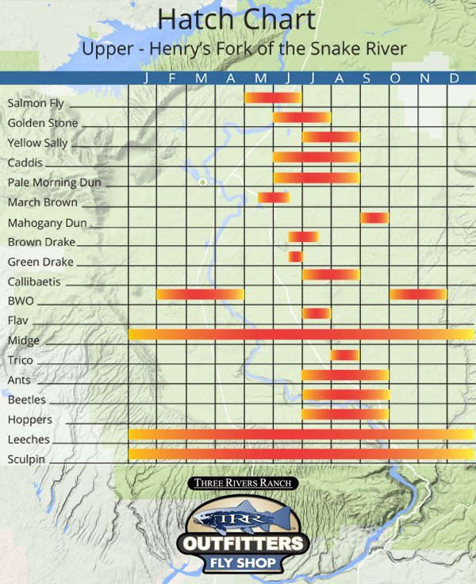

Weather and conditions: Mid-June so the days will be long. Water levels and clarity will depend on run off and snow melt. This area can get busy due to popularity, but it is worth it and there are other options. If travelling, consider fishing Henry’s Fork one day and exploring some of the other rivers the other days. This is a scenic area with lots to offer and long days to explore.

Link to Idaho Fish and Game for Henry’s Fork: https://idfg.idaho.gov/ifwis/fishingPlanner/water/1119497437574

QUESTIONS: Contact Paul Gray at paulgray206@gmail – or 206 915 6230 or Outings@bvff.com

The Harriman Ranch does not open to fishing until Saturday, June 15.

