October Caddis - Stimulator
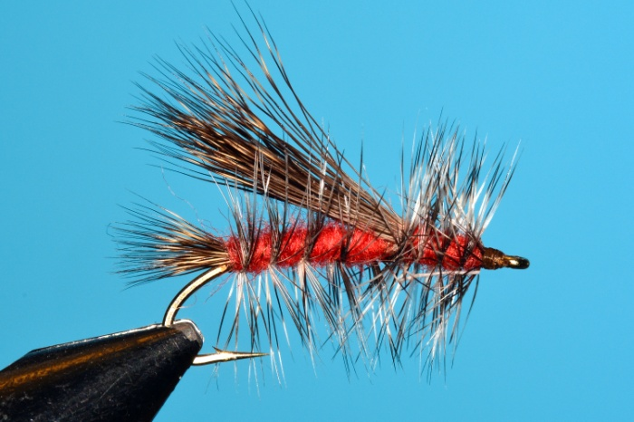
I’ll start with two questions. “Do you use an in-line rotary vise? Are you using it to its full potential?” Whether your answer is “yes” or “no,” the purpose of this presentation is to offer ideas on using it for more than just looking at the off side of the fly AND tips on tying with hair.

Stimulator Materials List
Hook: Curved nymph, 3-XL, size 4 to 20
Thread: Danville 6/0 brown (70 denier)
Tail: Deer or elk hair, stacked, length of gape
Hackle: Grizzly
Body: Orange dubbing
Wing: Deer or elk hair, stacked, length to tail’s end
Head: Orange dubbing, grizzly hackle

